Below are the test results from end to end testing:-

1. Wrong URL - If someone enters a wrong url then the below screen shows up.

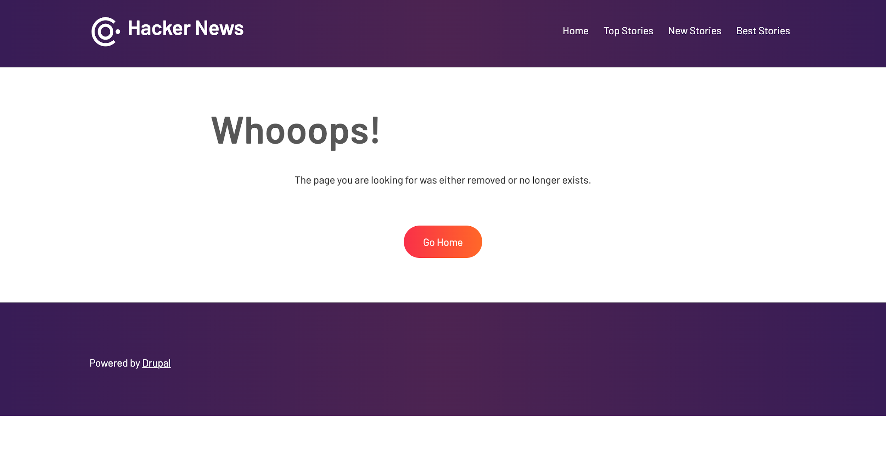

Test case 1 - PASSED

1. No Result Found - While using table filters if special characters entered or a text which is not present in the table, below screen appears. It says “No Matching Record Found”.

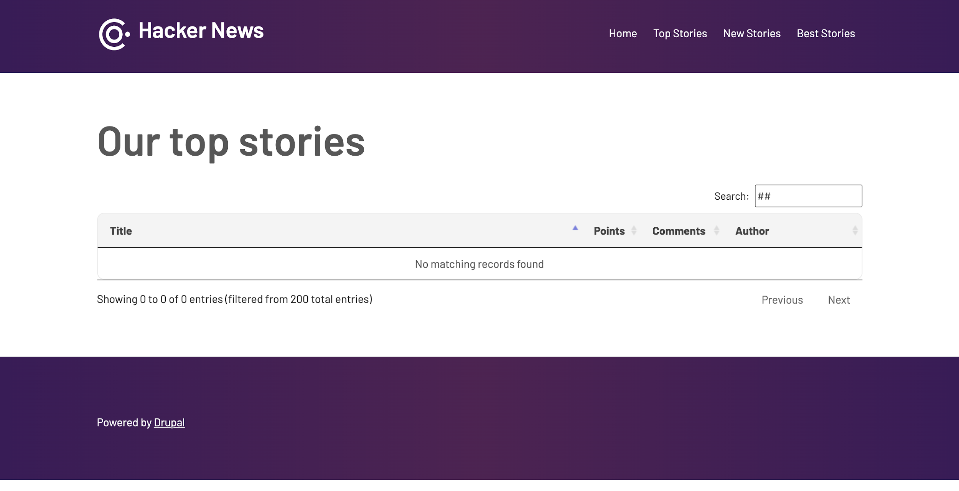

Test case 2 - PASSED

1. If there is only one page then next and previous buttons of pagination should be disabled.

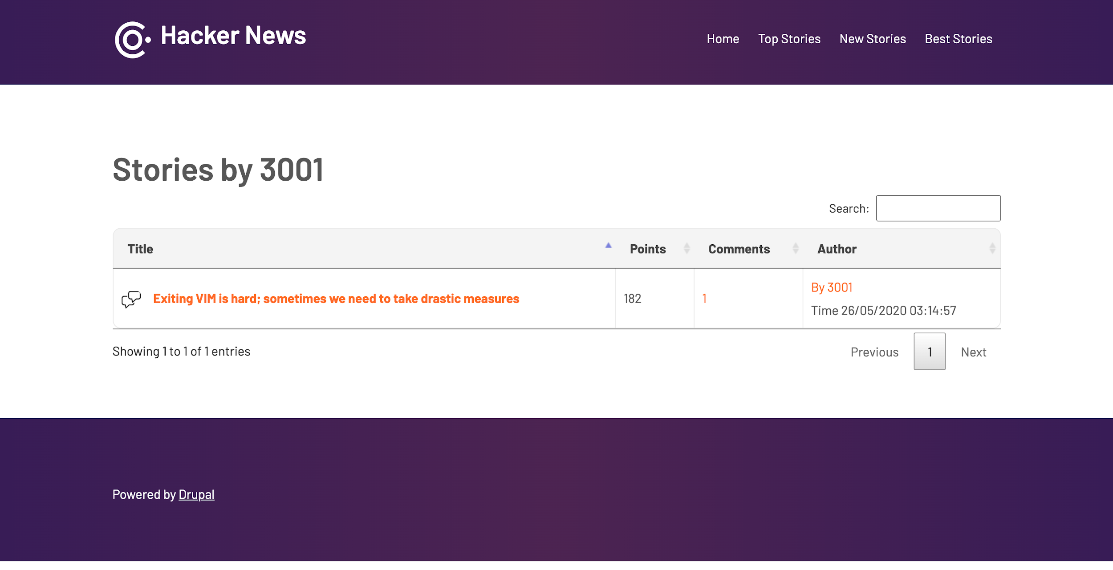

Test case 3 - PASSED

1. If there are no comments for the story then it should says “No Matching Record Found”.

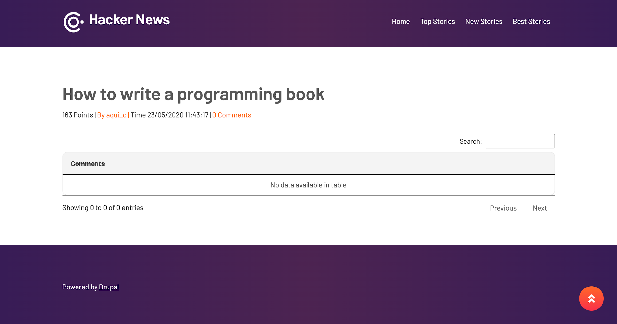

Test case 4 - PASSED